Syllabus
By Educational Program «5B070500-Mathematical and computer modeling»
fall semester 2019-2020 Academic year

Academic course information

Discipline’s code | Discipline’s title |  | IWS |  |  |  |  | Number of credits |  | IWST
 |  |  |  | Lect. | Pract. |  | Lab.
MA1204 | Financial Mathematics |  | 30 | 30 | 0 |  | 30 | 3 |  | 20.4
Lecturer |  | Kanat Shakenov, professor |  |  |  | Office hours |  |  | Scheduled
e-mail |  | E-mail: kanat.shakenov@gmail.com,
Telephone number |  | Telephone:  221-15-89 (кафедра) |  |  |  | Auditory |  |  | 410
Assistant |  | Altyn Baiteliyeva |  |  |  | Office hours |  |  | Scheduled
e-mail |  | E-mail: baiteliyevaaltyn@gmail.com
Telephone number |  | Telephone:  221-15-89 (кафедра) |  |  |  | Auditory |  |  | 201, 205

Academic presentation of the course | Aim of course: To acquaint students with the basic concepts of risk theory, as the theory of decision-making under conditions of uncertainty probabilities. Teach you how to predict future events and make decisions. Apply knowledge to the activities of insurance companies.  As a result of studying the discipline, students should be able to:  1. Deep knowledge of Monte Carlo algorithms.  2. Know the possibilities of modeling random variables along random processes (according to Markov chains).
Prerequisites | school math course
Post requisites | Mathematical analysis, Algebra, Geometry, Ordinary differential equations, Probability theory, Mathematical statistics, Random processes, Calculation methods, Computer science.
Information resources | literature:  - Новоселов А.А. Моделирование финансовых рисков. Лекции для студентов Института математики СФУ, Красноярск, 1998.  - Новоселов А.А. Основные понятия теории риска. Лекция для студентов математического факультета КГУ, Красноярск.  - Новоселов А.А. Математическое моделирование финансовых рисков. Теория измерения. Красноярск, 2001 г. 99 с.  - Шакенов Р.К. Математическое моделирование, оптимальное и  динамическое управление (хеджирование) портфелем ценных бумаг на рынке. Дисс. на соискание уч. ст. канд. физ.-мат. наук. КазНУ, Алматы, 2010 г. 143 с.  - Питер Джекел. Применение методов Монте – Карло в финансах. «Интернет - Трейдинг», Москва, 2004 г  Internet-resources: Additional educational material, lecture and practical classes, CDS assignments are uploaded to the teaching materials section of the univer.kaznu.kz website.
Academic policy of the course in the context of university moral and ethical values | Academic Behavior Rules: Compulsory attendance of classes, inadmissibility of lateness, compliance with deadlines for completion and delivery of tasks (CDS, seminars, intermediate exam).  Academic values: According to Article 5 of the Code of Honor of a student of Al-Farabi Kazakh National University, a student must strictly fulfill his academic duties and avoid academic and legal violations (plagiarism, forgery, the use of cheat sheets, deceiving the teacher and disrespectful attitude towards him, absenteeism and being late without respect reasons).  All students can receive advisory assistance in person, at the indicated phone numbers or through electronic correspondence.
Evaluation and attestation policy | Criteria-based evaluation: assessment of learning outcomes in accordance with descriptors (verification of the formation of competencies in midterm control and exams).  Summative evaluation: assessment of the presence and activity of work in the audience, assessment of the completed task.  The final assessment of discipline = 0.2 ∙ (RK1 + RK (MT) + RK2) +0.4 ∙ IR  RK1, RK2 - midterm control, MT - midterm exam, IR - final control.  Percentage-rating letter system for assessing students' academic achievements:  95% - 100%: А 90% - 94%: А- 85% - 89%: В+  80% - 84%: В 75% - 79%: В- 70% - 74%: С+  65% - 69%: С 60% - 64%: С- 55% - 59%: D+  50% - 54%: D- 25% -49%: FX 0% -24%: F

Calendar (schedule) the implementation of the course content:

Week / date | Topic title (lectures, practical classes, Independent work of students, IWS) | Number of hours | Maximum score
1 | 2 | 3 | 5
Module 1. Risk, insurance portfolios and insurance price
1 | Lecture 1. Uncertainty. Risk. Portfolio of risks. Insurance. Insurance portfolios. The simplest insurance portfolio. A simple insurance portfolio. Real insurance portfolio. | 2
 | Practical class 1. Exercise 2.1 | 1 | 8
2 | Lecture 2. The pricing principle. The principle of risk-free. The principle of justice. The principle of sufficient coverage. | 2
 | Practical class 2. Calculation of insurance premiums for simple and real portfolios. | 1 | 8
3 | Lecture 3. Portfolio heterogeneity. | 2
 | Practical class 3. Exercise 3.1, 3.2, 3.3. | 1 | 8
 | Independent work of student with teacher: IWST.  Сдача задания 1  “Calculate the main risk parameters. Study of the standard normal distribution property".  Test. |  | 30
4 | Lecture 4. Utility theory. Risk. Examples 4.1 - 4.6. | 2
 | Practical class 4. Exercise 4.1 – 4.3 | 1 | 8
5 | Lecture 5. . Algorithms for solving the difference analogue of the Dirichlet problem for the Poisson equation. Cases for n=2. | 2
 | Practical class 5 Exercise 4.4 – 4.9. | 1 | 8
 | Independent work of student with teacher: IWST.  Сдача задания 2 Proof of the existence theorem. Proof of Pratt's theorem.  Colloquium (orally). |  | 30
 | RK1 |  | 100
Module 2. Characterization of the attitude to risk
6 | Lecture 6. Solutions. Characterization of the attitude to risk. Attitude to risk. Neutrality. Risk appetite. Risk aversion. | 2
 | Practical class 6. Exercise 5.1 – 5.3. | 1 | 8
7 | Lecture 7. Quantitative expression of risk aversion. The price of risk. Risk aversion. Pratt's theorem. | 2
 | Practical class 7. Exercise 5.4 – 5.6. | 1 | 8
 | Independent work of student with teacher: IWST.  Сдача задания 3  “On the solution of difference equations of the second order.” |  | 30
8 | Lecture 8. The simplest risk process. Process description. The equation for the ruin probability. Calculation of ruin probabilities. A game with an infinitely rich adversary. | 2
 | Practical class 8. Numerical solution of a difference equation of the second order. | 1 | 8
9 | Lecture 9. The classic risk process. Definition The ruin of the process. The dependence of the probability of the ruin of the process on the parameters. | 2
 | Practical class 9. Volterra integral equation of the second kind. Numerical solution. | 1 | 8
10 | Lecture 10. Aggregated risk process. Aggregation operation. Devastation. Random walk. The equation for the ruin probability. | 2
 | Practical class 10. Example. The simplest risk process. | 1 | 8
 | Independent work of student with teacher: IWST.  Сдача задания 4 “The distribution of Pareto, Weibula, indicative.”  Colloquium (orally). |  | 30
 | RK |  | 100
Module 3. The risk processes
11 | Lecture 11. The lifetime of risk processes. The simplest risk process. | 2
 | Practical class 11. A simple risk process. The game of cat and mouse. | 1 | 8
12 | Lecture 12. The basic concepts of risk theory. Decision making problems. Risk. Attitude preference. Risk measure. Typical applications of risk theory. Portfolio analysis. Insurance. | 2
 | Practical class 12. Examples of risk measures. | 1 | 8
13 | Lecture 13. Solution of the problem for the ruin probability in the classical risk model with a Poisson flow of damage. | 2
 | Practical class 13. Properties of Poisson, Pareto, and Weibull distributions. | 1 | 8
 | Independent work of student with teacher: IWST.  Сдача задания 5 “Formulas of full probability and full mathematical expectation”  Test. |  | 30
14 | Lecture 14. The solution to the portfolio management problem by the criterion of capital growth rate. | 2
 | Practical class 14. Branching random process. Bernoulli distribution. Cox - Ross - Rubinstein model. | 1 | 8
15 | Lecture 15. Hedging a portfolio of securities in the 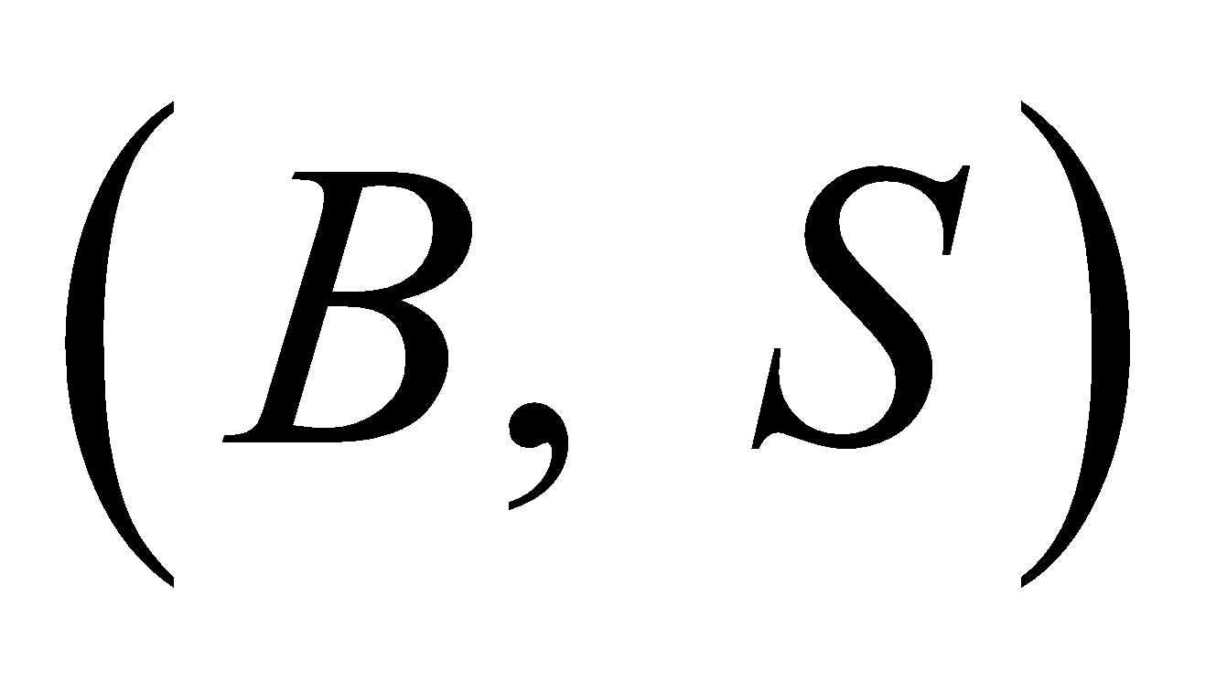 market. | 2
 | Practical class 15. Hedging. Upper and lower prices. | 1 | 8
 | Independent work of student with teacher: IWST. Portfolio of securities on the market. The financial condition and actions of the investor in the market.  Сдача задания 6  Colloquium (orally). |  | 30
 | RK |  | 100
 | Examination |  | 100
Note: Independent work of a student with a teacher is planned at 7 hours per semester. The syllabus is entered on the weeks specified by the teacher as assignments and / or consultations)

Lecturer________________ K. Shakenov

Head of the Department__________________ A. Issakhov

Chairman of the Faculty Methodical Bureau________________________ G. Abduakhitova

